IFG Explore

3rd Year Mystery Games

Term Three – Weeks One, two & three Physical & Interest
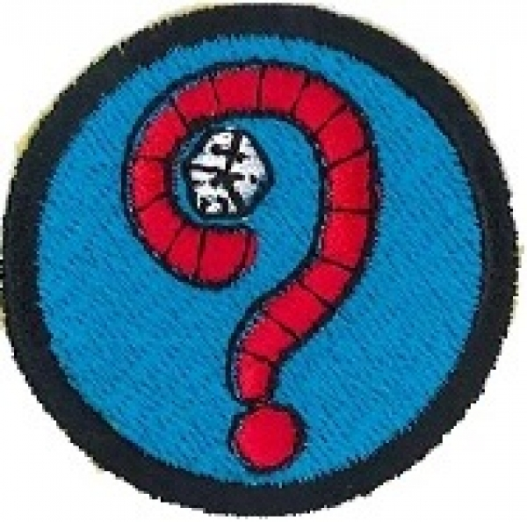
Aim: To enjoy a selection of Mystery games.

Coaches Tip:
Over the next three weeks choose from a selection of “Mystery” games. Mix up quiet sitting games with running around searching for clues games. Repeat favourite games as often as the girls ask for them.

Preparation:
- Any equipment necessary for games chosen.
- Equipment for Ten Commandments activity

SetUp:
Usual set up and roll call.

Devotions:
You may like to organise “Mystery guests” to come in and take devotions this term, or base your devotions on a question such as.......

Who rolled the stone away? (from Jesus’ tomb). Activity – give each girl an empty shoe box, scissors, glue etc. to make a tomb with a round stone to roll away.

“What are the Ten Commandments?”
If you choose the Ten Commandments you may like to spend two or even three weeks on this topic to reinforce the learning.
The activity below would take two weeks for the girls to complete.
Ten Commandments on Parchment:
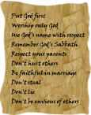
This project gives the girls the opportunity to "rewrite" the Ten Commandments in more modern language. Combining this exercise with creating their own parchment makes for a fun and educational craft.

Materials:
- cold coffee or tea (about 1/2 cup),
- piece of white paper,
- a blow-dryer,
- some markers.
Instructions:
Take a piece of nice white paper and rip off all the edges (don't cut them with scissors, rip them!) If you rip the paper a bit more than you meant to, it's not the end of the world.
Crumple the paper up as tightly as you can into a ball.
Flatten the paper out again and put onto a plate or cookie sheet. (If you haven't told the girls what you're doing, they'll start thinking you're really weird right about now).
Pour coffee or tea over the paper. Swoosh around with your hands to make sure it covers everything.
Let it sit while you brainstorm with the girls using a whiteboard or a large piece of paper what the Ten Commandments might look like when written in modern language.
Pour off the coffee / tea into the sink. Leave paper on the plate.
Blow dry with a hairdryer lowering the setting to finish off or leave to dry until next week when the girls can then write the modernised Ten Commandments on to their parchment paper (or use the original Commandments if that is your preference).

Optional: You can roll the parchment up and slip into a cardboard roll which you can decorate with markers or stickers or you can tie with a ribbon to make a rolled up scroll.

Here is an idea of what your modernized 10 commandments might look like:
- Put God first
- Worship only God
- Use God's name with respect
- Remember God's Sabbath
- Respect your parents
- Don't hurt others
- Be faithful in marriage
- Don't steal
- Don't lie
- Don't be envious of others

Teaching Session:
Start the term with a discussion on “mystery” to gauge the girls’ level of understanding of this topic and to get them in the zone.

Here is a list of words associated with solving mysteries:
Alibi A reason offered by an n person for not having been at the scene of crime.
Clue Something that appears to give information toward solving the crime.
Deduction Collecting the facts and drawing a possible conclusion.
Evidence Someone or something that proves who committed the crime.
Red herring A false lead that throws the investigator off track.
Sleuth An investigator or detective.
Suspects People who appear to have a motive to have committed the crime.
Witness Person who has personal knowledge about the crime.
( Girls love the idea of the “red herring”).

Mystery Games:
“Who’s drawing snakes on your back and who tipped your finger?”
Break girls into small groups so everyone gets a turn. One girl is “in”. She turns her back to the group with one hand behind her back with first finger extended and hides her eyes. One girl is chosen to trace “snakes” on the back with her first finger and then tip the finger of the girl who is “in” while all the group chant “Who’s drawing snakes on your back and who tipped your finger. Once the girl who is “in” correctly identifies the girl who tipped her finger, that girl is “in”.

“Keys to the Castle”
There is sure to be one leader who has a big bunch of jangly keys. Girls sit in a circle. Leader chooses one girl to be the “queen” to sit blindfolded on her throne (a chair in the middle of the circle) with the bunch of jangly keys on the floor under the chair. The leader points to a girl in the circle who must retrieve the keys as quietly as possible, return to her place in the circle and hide the keys. The girl on the chair is unblindfolded and must guess who “stole” the keys. Once she has identified correctly she takes the place of the “stealer” and the “stealer” has a turn as “queen”.

“Hot and Cold”
Choose one girl to be “it” and get her to leave the room. Then choose a “Mystery Object”. It could be something one of the girls is wearing like a hair accessory or the third button down on a jacket; or it could be something in the room like the light switch. Once the “Mystery Object” has been chosen the girl who is “it” comes back in to the room and has to try to find the object. If she moves away from the object everyone yells “cold”. When she moves nearer everyone yells “hot”. Once she has found the object everyone yells “Fire”. (But not too loudly or the fire warden may come running in!)

“Jigsaw Puzzles”
Get girls to complete a jigsaw puzzle without knowing what the completed puzzle will look like. May work in small groups for this. The picture is a mystery until the pieces are put in to their correct place.

“Mystery Bag”
Have an interesting looking bag or sack. Say, one made out of red velvet. Place inside several random items. Girls have turns to feel the articles inside the bag and try to guess what they may be.

“Mystery Eats”
Preparations: Wrap food items in aluminium foil. (Check food allergies before preparing for this game).
Equipment: Portions of different foods wrapped in foil for each player, two paper sacks
Divide the group into two teams. Place two sacks of Mystery Eats at the other end of the room, one for each team. The first player from each team has to run across the room to the sack, pull out one of the foil-wrapped food portions, and eat it. No exchanges allowed! When finished eating, the player runs back and tags the next player on the team, who repeats the action. The winning team is the first to have all their players eat one item.
Ideas for foods include bread, raw onion, candy, cold pizza, chocolates, cheese, radish, etc. Warn the players that they could be in for a shock!

“Detective”
This is an excellent game to be played as a group. Girls must work together as detectives in this game. Choose one room and allow the girls time to look around and familiarize themselves with the room. Then send them out of the room and take one object out. Bring them back into the room and give them time to figure out what is missing. After a length of time, give the group up to 3 chances to guess the missing item.
*Optional: To make the game more detective-like, place clues around the room that might enable the players to figure out the missing object. Clues can be in the form of notes that lead to other clues.

Cinderella’s and Princes’:
Ask the girls to remove their shoes. Place all of the shoes neatly in one room. Once you have all the shoes, invite girls one by one, to come and pick out one shoe that does not belong to them. The girls must then mingle and try to find the owner of the shoe they have chosen. They can ask potential candidates to try the shoe on. The game ends when everyone gets their shoes back.

Ringleader:
Have all the players sit in the circle except one player who is “It.” It must leave the room while the players in the circle choose a secret leader. The leader demonstrates a gesture. For example, pulling one ear, patting the stomach, tapping a foot, etc. Everyone in the circle copies the gesture. “It” returns to the middle of the circle and sees everyone making the gesture. The secret leader may change the gesture at any time by starting a new one. All the players in the circle except “It” must copy the gesture. The object of the game is for “It” to guess who the secret leader is that is creating the gestures. After several minutes, if “It” cannot guess the leader, have another player become “It” and select a new leader. The game can continue until players’ tire of guessing or everyone has had an opportunity to be “It”.

Outdoor games could be based on orienteering / Treasure Hunt type activities.

